CHILDREN’S COURT OF VICTORIA

COURT PERFORMANCE

INTERVENTION ORDER CASES
(FAMILY VIOLENCE & PERSONAL SAFETY)

Cases initiated 2011/12 – 2014/15
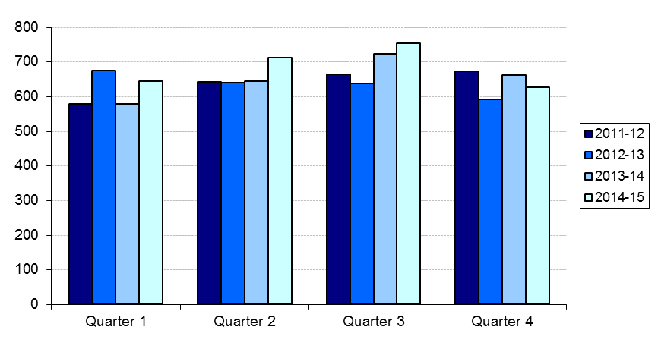
Cases finalised 2011/12 – 2014/15
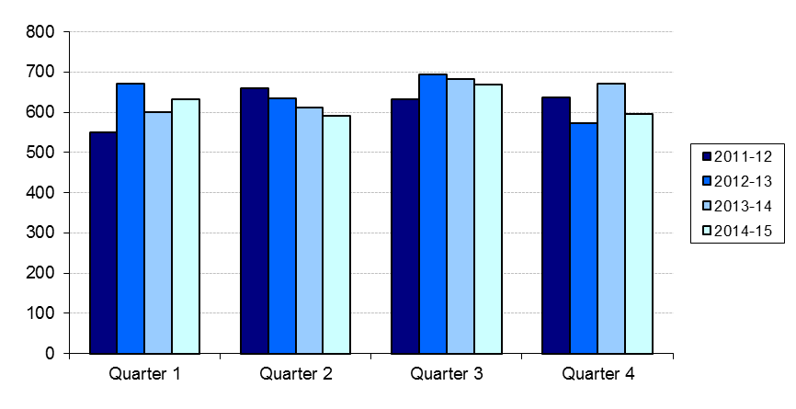
Clearance rate 2011/12 – 2014/15
