CHILDREN’S COURT OF VICTORIA

COURT PERFORMANCE
CRIMINAL CASES

Cases initiated 2011/12 – 2014/15

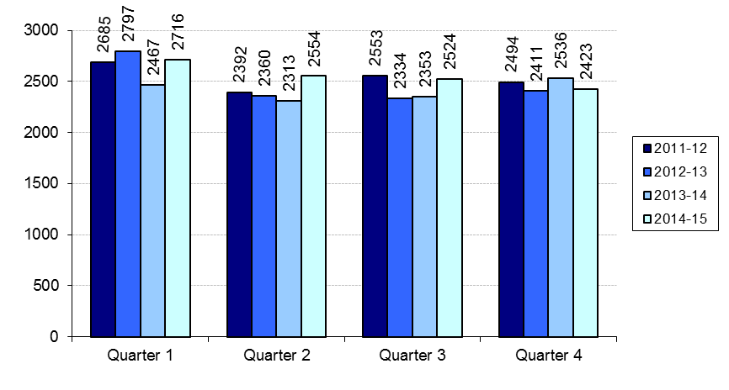
Cases finalised 2011/12 – 2014/15

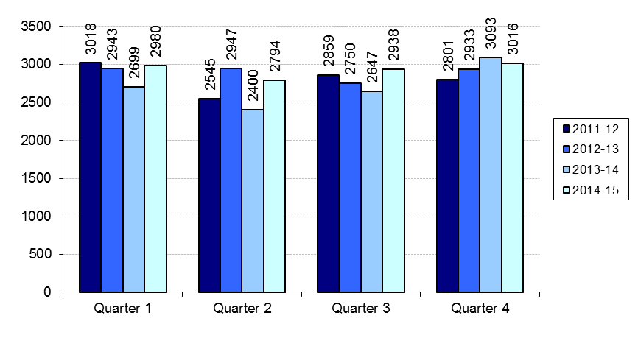
Clearance rate 2011/12 – 2014/15

